**System Development Technology**

**CA3 Individual Assignment**

**July 2023 Semester**

|  |  |  |
| --- | --- | --- |
| **No.** | **Name** | **SIM Student No.** |
| L1. | Angeles Micah Josephine Flores | 10240945 |
| M2. | Sumcad Bryce Nicolas Fernandez | 10244185 |
| M3. | Ho Ka Yan Jeslyn | 10241485 |
| M4. | Wilson Wong | 10239962 |
| M5. | Chea Darayuth | 10240675 |

**Group 8**

**Date of Submission: 14 August 2023Table of Content**

1 Introduction 3

2 Question 1 (System Vision Document) 4

3 Question 2 7

3.1 Non Functional Requirement 7

3.2 Functional Requirement 9

4 Question 3 10

4.1 Use Case Diagram 10

4.2 Use Case Description 12

4.3 Sequence Diagram 29

5 Question 4 32

5.1 Design Class Diagram 32

5.2 Package Diagram 34

5.3 CRUD Table 35

6 Question 5 36

7 Question 6 37

8 Conclusion 38

9 Appendix 39

# Introduction

Due to the unpredictable growth of technology, commercial transactions in the modern world are happening at a rapid pace. With the advancement of technology in company operations, smaller and larger businesses can now compete on an equal level. In order to successfully improve customer experiences and increase revenue, many businesses embrace digital tools and solutions as a foundation and business strategy.

For our group project, we had decided to work with the food and beverage firm, Menya Musashi in order to enhance customer experiences and boost revenues. Our objective is to investigate how we can help restructure the business to succeed the digital world by examining the issues they faced and implementing new services to assist them. The whole process and methods, as well as the technologies and tactics we used to accelerate this business' transformation, will be detailed in this research project. Enabling the sustained growth in the companys’ technological age through increased sales, and improved interactions with clients.

# Question 1 (System Vision Document)

**System Vision Document**

**Menya Musashi System**

**Problem Description**

The online platform encounters several difficulties that limits their capability to build trusting relationships with customers and provide personalised and custom-tailored experiences.

One of the biggest concerns the company faces is the steep decline of active customer engagement. These customers visit the website sporadically, resulting in a steep decline of user interaction as well as decreasing the number of customer visits.  
Building lasting connections and encouraging customer loyalty is significantly impeded by the low customer involvement.

Furthermore, the present platform lacks membership capabilities that cater to what the customer needs. The absence of these membership benefits hinder both the business and the customer’s experience through the lack of customer engagement. As a result, the company may overlook crucial insights and possibilities for potential developments. (*Menya Musashi, 2023)*

Moreover, customers are increasingly seeking personalised and custom-tailored experiences that are centred around their own interests and needs. However, the company’s present platform falls short in delivering the best customer experience by not taking into account customer expectations. The absence of additional order options and custom-tailored experiences causes a steep decrease in customer satisfaction as well as how the customer values the company’s overall importance in their life.

Thirdly, convenience is paramount in the minds of our customers when it comes to making transactions. Unfortunately, the platform offers limited payment options, inconveniencing customers and deterring potential transactions. This limitations restricts the company’s ability to capture a broader base and capitalise on revenue opportunities.

Lastly, valuing and appreciating their customers’ loyalty and contributions are.

It is recommended that the new functions listed below, to be implemented to Menya Musahi’s official website, can help the company grow their online services and help them gain more revenue through those online services that have been recommended . Moreover, It is also a way for customers to enjoy the rich, brothy ramen in the comfort of their own home. This system can benefit the customers of the modern online world.

**System Capability**

* **Digital Membership Benefits:** you have access to exclusive benefits only available for members such as
  + - **Exclusive Ramen Delivery Kits**: Introduce Ramen packages or limited-time offers exclusively available for online ordering, creating a sense of exclusivity. On these kits, there is a QR code that the customer can scan which will lead them to login to their account and view how to cook their packages.
    - **Virtual Events and Cooking Classes**: Host virtual events, like live cooking demonstrations and a Q&A session for members to join and follow along in the comfort of their own home

**Business Benefits**

Deployment of this new system will provide the following business benefits to Menya Musashi

* Increase customer loyalty by adding exclusive deals and perks for members
* Advantage among competitors through unique functions such as delivery ramen packet delivery, recipe sharing, and a user-friendly mobile app.
* With the help of technology, MenyaMushashi will be capable of taking multiple customer’s data through their membership and efficiently receive and create the customer’s order.

# Question 2

A System requirement document is a document that provides a list of in-depth explanations of what the system should have to support the system and the restrictions and other expectations it must meet. This is necessary to ensure that the system is developed with the user or client’s demand in mind. System requirement document are made up of two categories, non-functional and functional requirement

## Non Functional Requirement

A set of standards known as non-functional requirement that reveal the system’s operational features and drawbacks while simultaneously attempting to enhance the functionality. The FURPS techniques, which represent as usability, reliability, performance and security can used to convey the non-functional requirement.

**Usability**

* It can be access via mobile and laptop
* It is User friendly, Customers can swiftly place orders, facilitating a smooth easy ordering procedure.

**Reliability**

* On a daily basis at 4AM, the server’s system will perform an automated backup.
* The system is accessible from 5AM to 12PM

**Performance**

* A maximum of 250 simultaneous interactions can be handled by the server.
* Ensure that the server response speed is between 100ms and 200ms.

**Security**

* To avoid malware and other harm such as ransomware, the system will employ antivirus applications.
* In the server, use secure passwords and multi-factor authentication.
* Keep track on the server's data logs to see who has logged in.
* Encryption protections confidential information whether it is stored on a server or transiting through a network.
* To improve the safety of your servers and safeguard your data from dangers, enable remote access via a VPN server.

## Functional Requirement

**Membership subsystem**

* As a customer, I want to join as a member, so that I can get membership benefits
* As a member, I want to view membership benefits, so that I can take full advantage of my membership and know what benefits I might get.
* As a member, I would like to purchase the ramen exclusive kits, so that I can prepare my own ramen whenever I please.
* As a customer, I want to use the QR Code payment, so that I don't have to provide my card number, and the company can't access my bank information.

**Management Subsystem**

* As a Manager, I want to create a cooking class, so that members can join the class.
* As a Manager, I want to delete a cooking class with few students, so that the class can be used more profitably.
* As a Manager, I want to view the time-slot of each class, so that I can be informed of how many attendees are going for each class.
* As a Manager, I want to update the time-slot, so that students can see the available classes.

**Virtual cooking class Subsystem**

* As a member, I want to view the time slot available so that I can book a class.
* As a member, I want to make a booking, so that I can join the virtual cooking class.
* As a member, I want to cancel the cooking class booking so that I could attend other more crucial events.

# Question 3

## Use Case Diagram

**Membership Subsystem**

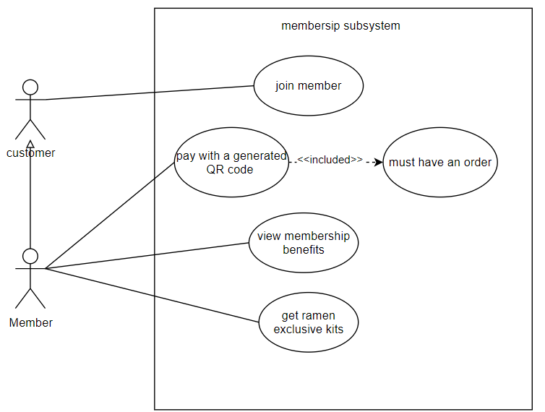

**Management Subsystem**

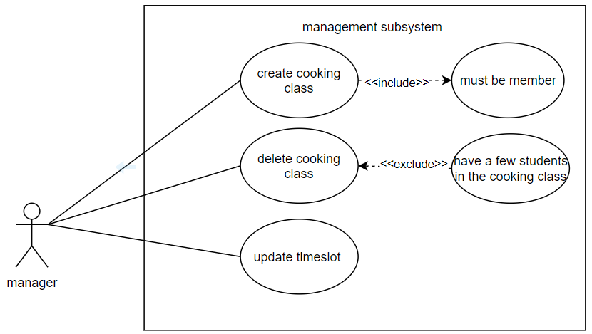

**Virtual Cooking Class Subsystem**

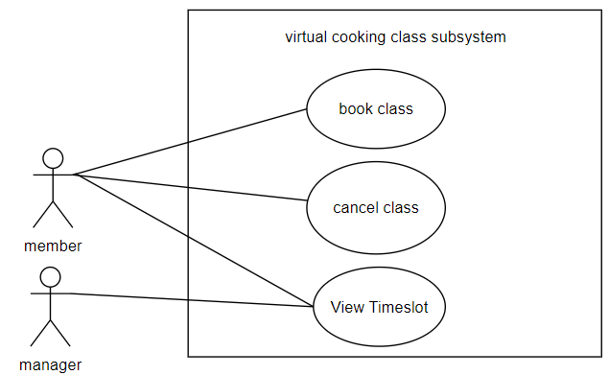

## Use Case Description

**Membership Subsystem**

Apply Membership

|  |  |  |
| --- | --- | --- |
| Use Case Name | Apply Membership | |
| Scenario | Customer would like to apply for the membership to be able to utilise exclusive membership benefits/perks | |
| Triggering Event | Customer is drawn by the exclusive benefits of being a member and expresses interest in applying for a membership | |
| Brief Description | Customer applies to become a member to be able to access exclusive membership perks such as being able to earn loyalty points and Ramen Delivery Kits | |
| Actors | Customer | |
| Related Use Cases |  | |
| Stakeholders | Customer | |
| Preconditions | Customer is required to provide the necessary information (e.g. Name, Phone Number, Birthday , Email ,  Address )  Customer should be aware of the terms & conditions as well as the exclusive perks included in the membership  Membership Subsystem must be available | |
| Postconditions | Customer application status should be updated accordingly whether it is :  1) Processing  2) Approved 3) Rejected  Customer should get a confirmation email and their unique member ID once their application has been approved  Customer receives email confirmation and membership approval | |
| Flow of Activities | Actor | System |
| 1. Customer applies for membership  2. Customer fills up the membership application form by providing the necessary information  3. Customer submits the application once completed | 1.1 System showcases the terms & conditions as well as the exclusive perks included in the Membership  2.1 System checks whether the application has been completed correctly  3.1 System sends an acknowledgment email to the Customer once application has been processed |
| Exception Conditions | 2.2 System will not process with the application and prompt the Customer if a field has yet to be filled up | |

View Membership Benefits

|  |  |  |
| --- | --- | --- |
| Use Case Name | View Membership Benefits | |
| Scenario | Members desire to explore the types of perks so that they may fully utilize their memberships | |
| Triggering Event | Members login to their account and view the membership benefits section | |
| Brief Description | Members desire to view and use the advantages and benefits of membership. | |
| Actors | Member | |
| Related Use Cases | Apply Membership | |
| Stakeholders | Member | |
| Preconditions | Only members can view and use the benefits. | |
| Postconditions | Display membership perks | |
| Flow of Activities | Actor | System |
| 1. Members access the membership benefit page. | 1.1 System Display the benefits |
| Exception Conditions | Website is down | |

Purchase Ramen kit

|  |  |  |
| --- | --- | --- |
| Use Case Name | Purchase Ramen Kits | |
| Scenario | Member wants to buy and cook premade ramen | |
| Triggering Event | Member wants to buy cooking Ramen kits for later use | |
| Brief Description | Members have an additional order option to buy the disposable ramen cooking kits so they can have exclusive ramen at their own time | |
| Actors | Member | |
| Related Use Cases | Apply for Membership, View membership benefits | |
| Stakeholders | Member | |
| Preconditions | Customer must be registered as Member  Member info must be saved  Exclusive ramen kits must be available | |
| Postconditions | Member can purchase the disposable Ramen exclusive kits to make their own personal customize Ramen recipe and it is portable that they could brought everywhere or cooking at home using provided utilize or ingredients | |
| Flow of Activities | Actor | System |
| Member order the exclusive kits | 1.1 System check whether the account is eligible to buy the exclusive kits |
| Exception Conditions | 1.2 System will not approve if account is not member | |

Make Online Payment

|  |  |  |
| --- | --- | --- |
| Use Case Name | Make Online Payment | |
| Scenario | Customers want to use other online payment options instead of inputting their credit or debit card number. | |
| Triggering Event | Customer wants to make an online purchase of ramen | |
| Brief Description | Customers prefer to use GrabPay/ApplePay/PayNow for payment rather than typing in their credit or debit card information. | |
| Actors | Member | |
| Related Use Cases | Purchase Exclusive Ramen Kits | |
| Stakeholders | Member | |
| Preconditions | Member has added the ramen want to purchase to their cart  Order Subsystem must be available | |
| Postconditions | Customer will get confirmation that payment was successful | |
| Flow of Activities | Actor | System |
| 1. Member select their mode of payment from the list of options  2. Member scans QR code and inputs the amount.  3. Member receives notification that payment was successful. | 1.1 System provides a list of payment options to the Member.  2.1 System receives notification that the Member has made a transaction.  2.2 System accepts payment and notifies the Member  that payment was successful. |
| Exception Conditions | 2.1 Payment was unsuccessful | |

**Management Subsystem**

Create Virtual Class

|  |  |  |
| --- | --- | --- |
| Use Case Name | Create Virtual class | |
| Scenario | Manager decided to allow members to participate in virtual cooking class in a different variety of methods and dishes. | |
| Triggering Event | Manager decides to host a cooking class for members to enhance loyalty to the restaurant. | |
| Brief Description | Manager arranges a cooking class where participants can learn from a professional chef how to prepare the dishes and cooking techniques they want. | |
| Actors | Manager | |
| Related Use Cases |  | |
| Stakeholders | Manager | |
| Preconditions | website needs to be available | |
| Postconditions | Notified to the Manager that a cooking class is created | |
| Flow of Activities | Actor | System |
| 1. Manager create a class  2. Manager received a notification that a class is created | 1.1 System updates the report and the website.  1.2 System sent a notification that a class has been created to the manager |
| Exception Conditions | Technical error in the system | |

Delete Virtual Class

|  |  |  |
| --- | --- | --- |
| Use Case Name | Delete Virtual Class | |
| Scenario | The manager wants the cooking class to be deleted, when the minimum enrolment is not met. | |
| Triggering Event | Manager wants to know if the requirements are in order to conduct the class. | |
| Brief Description | Manager sees the report of a certain cooking class minimum enrollment requirement has been met for that particular time slot,  before confirming to conduct the class | |
| Actors | Manager | |
| Related Use Cases | View Timeslot | |
| Stakeholders | Manager | |
| Preconditions | Website needs to be available  Manager Subsystem must be available | |
| Postconditions | The minimum enrolment requirement must be met for each class | |
| Flow of Activities | Actor | System |
| 1. Manager want to access the cooking class report  2. Manager checks if the conditions are met. The Manager deleted the class when the minimum enrolment in a class did not meet. | 1.1 System generate a report, and display it for the manager.  2.1 After deleting, the system will be alerted and will update the report for the cooking class. |
| Exception Conditions | 1.1 The website have technical issues | |

View Timeslot

|  |  |  |
| --- | --- | --- |
| Use Case Name | View Timeslot | |
| Scenario | Manager will be able to view the Timeslots for the Virtual Cooking Classes available so that they know how many Members have successfully signed up | |
| Triggering Event | Manager accesses the Virtual Cooking Class timeslot for the available classes to be able to be more informed of the number of signups for each class | |
| Brief Description | The manager wants to view the timeslots for the virtual cooking classes to be informed of how many members are attending the virtual cooking classes | |
| Actors | Manager | |
| Related Use Cases |  | |
| Stakeholders | Manager | |
| Preconditions | The Management subsystem must be available | |
| Postconditions | The manager is able to view the timeslots and be informed on the number of members who attended | |
| Flow of Activities | Actor | System |
| 1. Manager want to access the View timeslot report | 1.1  The system will then display the timeslot report. |
| Exception Conditions | The website is experiencing technical issues | |

Update Timeslot

|  |  |  |
| --- | --- | --- |
| Use Case Name | Update Timeslot | |
| Scenario | Manager would like to be able to update the timeslot for the Virtual Cooking Class so that they are able to efficiently administer the schedule and provide members accurate timings for the Virtual Cooking Class | |
| Triggering Event | Manager recognises the need to change the timing for the Virtual Cooking Class | |
| Brief Description | Manager will be able to manage the timeslot for the Virtual Cooking Classes and be able to accommodate to changes with regards to the schedule or demand | |
| Actors | Manager | |
| Related Use Cases | View Timeslot | |
| Stakeholders | Manager | |
| Preconditions | The Manager is required to log into the system  There should be an exisiting Virtual Cooking Class session  The Virtual Cooking Class has yet to start so that the information is accurate and relayed effectively | |
| Postconditions | The Timeslot for the Virtual Cooking Class should be updated successfully  Manager and Customer will be notified of the change or updates done on the Virtual Cooking Class | |
| Flow of Activities | Actor | System |
| 1. Manager logs into the system to update the Timeslot  2. Manager selects the specific Virtual Cooking Class to update  3. Manager updates the Timeslot for the selected Virtual Cooking Class | 1.1 System will display the following Virtual Cooking Classes  2.1 System displays the details of the selected Virtual Cooking Class and the current Timeslot  3.1 System will prompt the Manager about the modifications done to the Timeslot  3.2 Members who have successfully signed up for the specific Timeslot will be notified of the change via email |
| Exception Conditions | 3.1 System will prompt the Manager that the modifications were not done/ rejected as it clashes with another Virtual Cooking Class Timeslot | |

**Virtual cooking class Subsystem**

View Virtual Class

|  |  |  |
| --- | --- | --- |
| Use Case Name | View Virtual Class | |
| Scenario | Member wants to see what are the available times for a cooking class | |
| Triggering Event | Member wants to learn from the cooking class, so the customer checks what are the available times for cooking class | |
| Brief Description | Member wants to view and choose from a list of available time slots for the cooking class | |
| Actors | Member | |
| Related Use Cases |  | |
| Stakeholders | Member, Manager | |
| Preconditions | Management Subsystem must be available  Virtual Cooking Class Subsystem must be available | |
| Postconditions | Member has knowledge of the available time slots | |
| Flow of Activities | Actor | System |
| 1. Member opens the cooking class time slots  2. Member looks through the available time slots    3. Member confirms selection of time slot | 1.1 System shows available time slots to customer  1.2 System gives the customer the ability to browse through available time slots  2.1 System asks if they want to enroll in this time slot |
| Exception Conditions | 2.1 Customer doesn’t confirm selected time-slot | |

Cancel Booking

|  |  |  |
| --- | --- | --- |
| Use Case Name | Cancel Booking | |
| Scenario | Member cancels the booking they made for cooking class | |
| Triggering Event | Member decided they want to cancel the booking they made for class | |
| Brief Description | Member cancels the class booking through the mobile app/website | |
| Actors | Member | |
| Related Use Cases | View time slot | |
| Stakeholders | Member | |
| Preconditions | Membership subsystem must be available  Members are required to View time slot first.  Customer booked a Virtual Cooking Class | |
| Postconditions | The customer will get notified that their cooking class booking has been cancel | |
| Flow of Activities | Actor | System |
| 1. Member cancels the booking  2. Member received a notification, that they have cancel a cooking class booking | 1.1 Systems update the cooking class report.  1.2 System sent a notification to the member, that they have a cancel a cooking class booking |
| Exception Conditions | Website/mobile app is experiencing technical difficulties | |

Make Booking

|  |  |  |
| --- | --- | --- |
| Use Case Name | Make Booking | |
| Scenario | Members want to book a cooking class | |
| Triggering Event | Member book the booking they made for cooking class | |
| Brief Description | Members decided they want to join a cooking class. | |
| Actors | Member | |
| Related Use Cases | View time slot | |
| Stakeholders | Member | |
| Preconditions | Membership subsystem must be available  Members are required to View time slot first. | |
| Postconditions | The customer will get notified that they had book a class | |
| Flow of Activities | Actor | System |
| 1. Member book a Cooking class  2. Member received a notification, that they have a book a cooking class | 1.1 System update the cooking class report.  1.2 System sent a notification to the member, that they have a book a cooking class |
| Exception Conditions | Website/mobile app is experiencing technical difficulties | |

## Sequence Diagram

**Membership Subsystem**

1. Apply membership

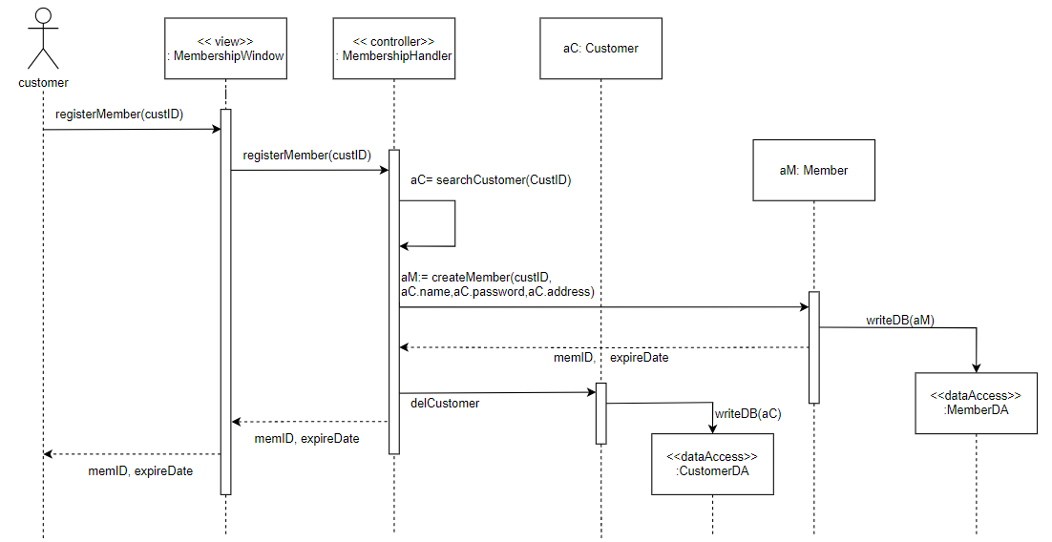

2. View membership benefits

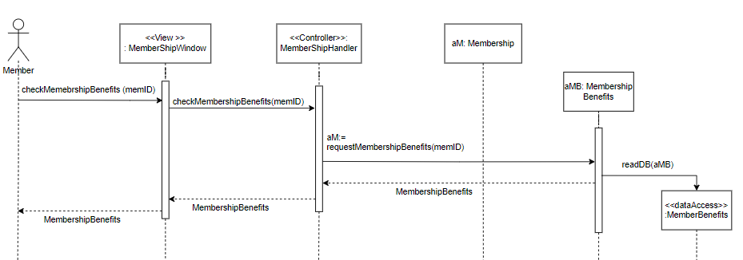

3. Purchase ramen kit

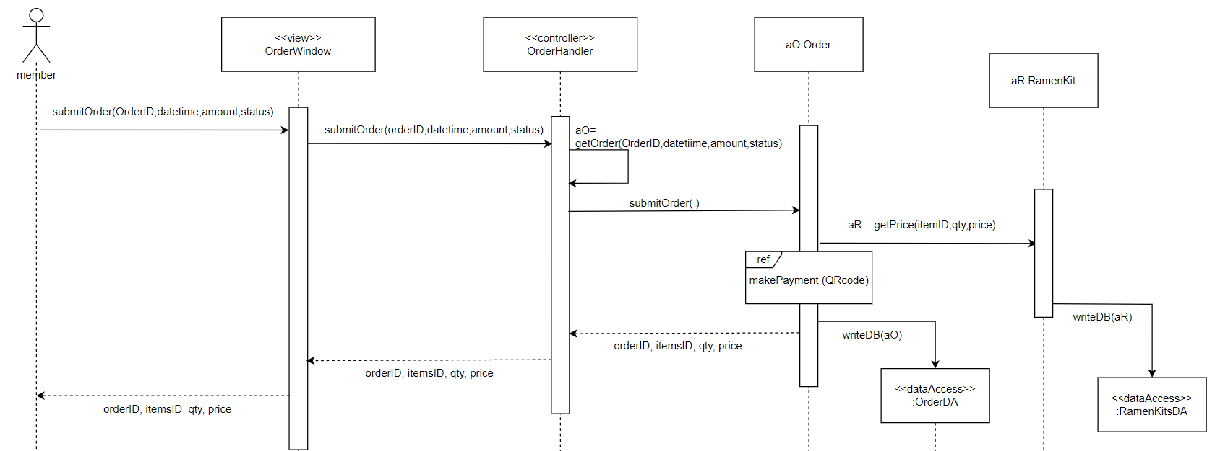

4. Make online payment

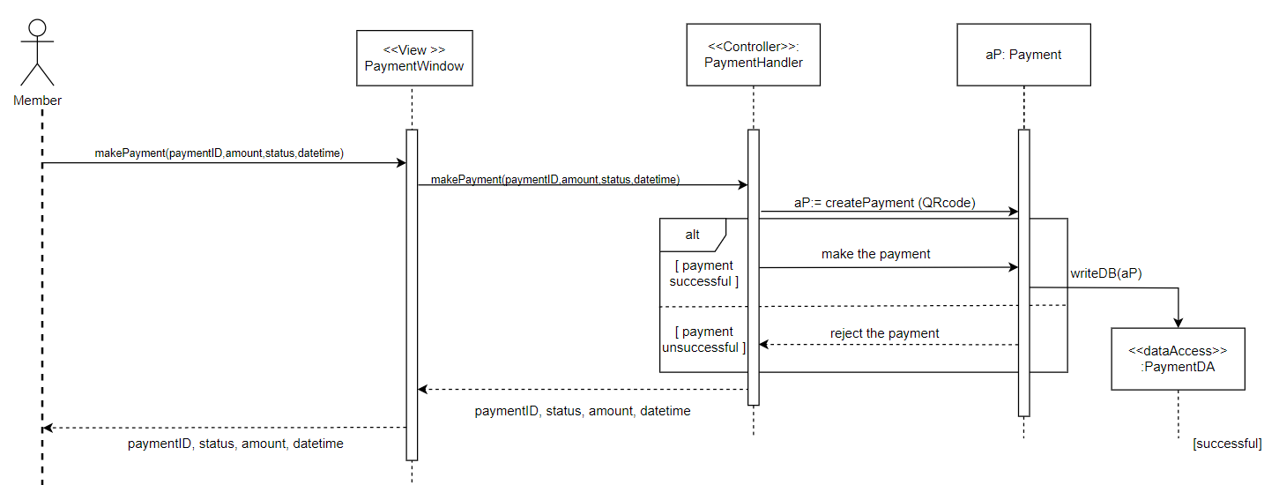

5. View timeslot (member can access)

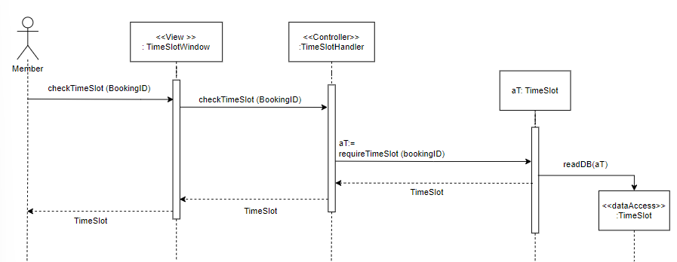

**Virtual Cooking Class Subsystem**

6. Cancel Booking

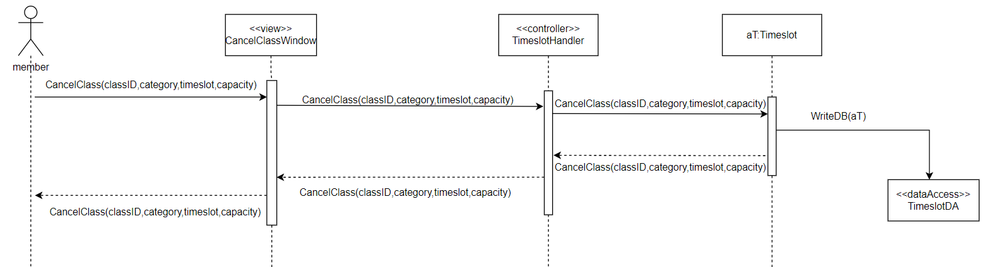

7. Make Booking

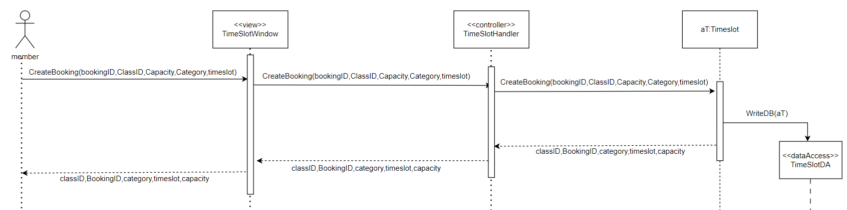

**Management Subsystem**

8. Create Virtual Class

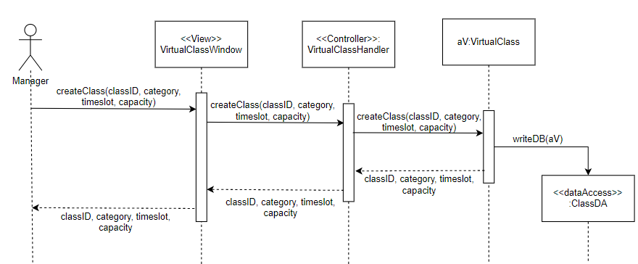

9. Delete Virtual Class

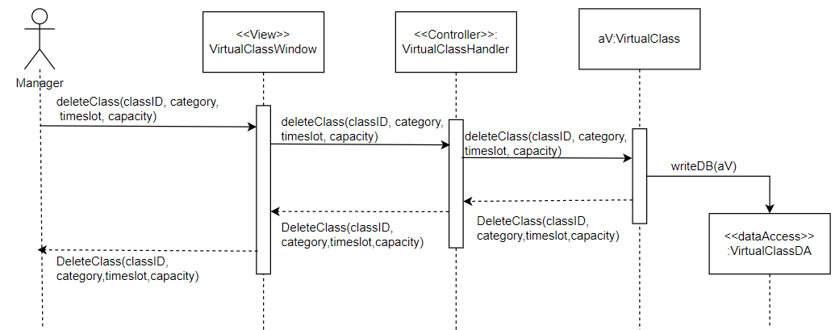

10. Update Cooking Class

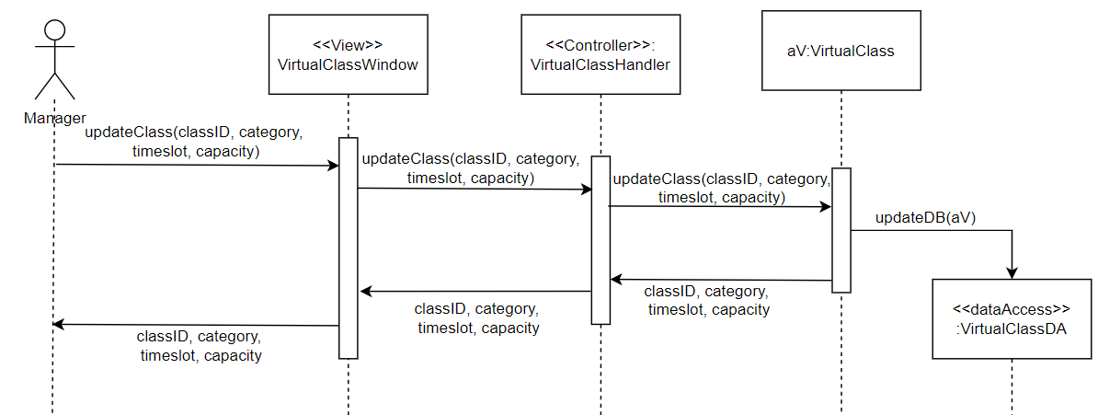

11. View Cooking Class

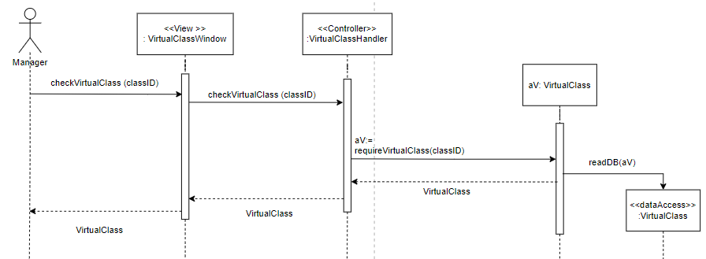

# Question 4

## Design Class Diagram

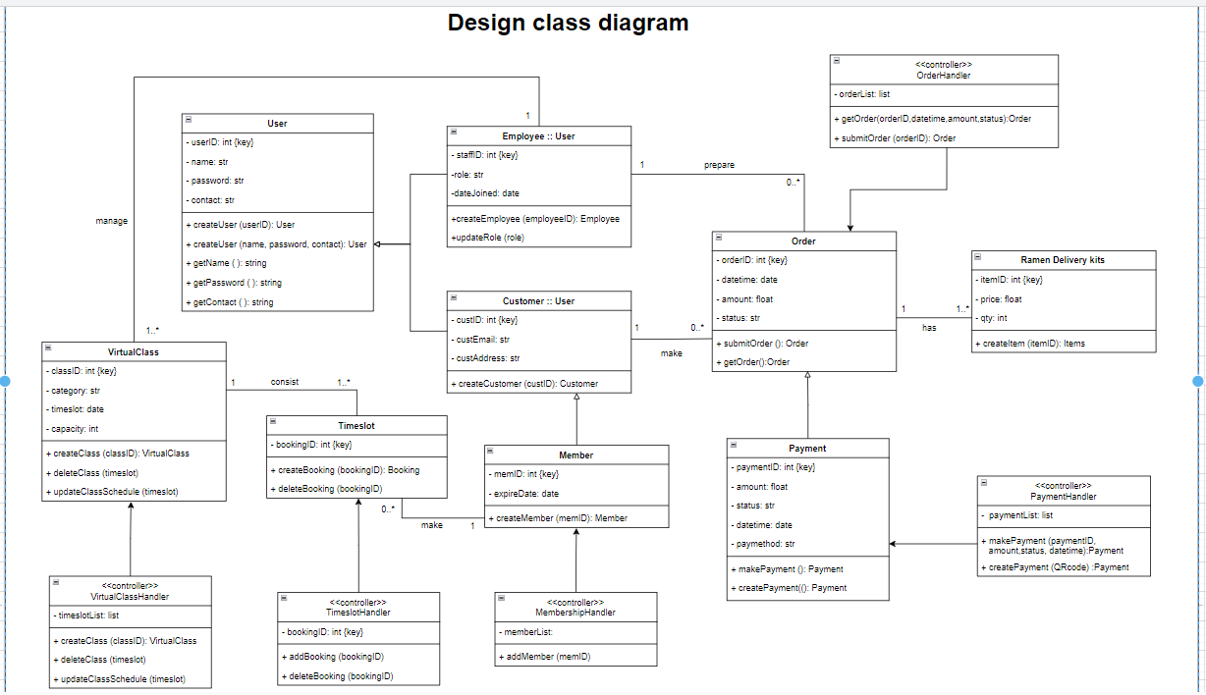

## Package Diagram

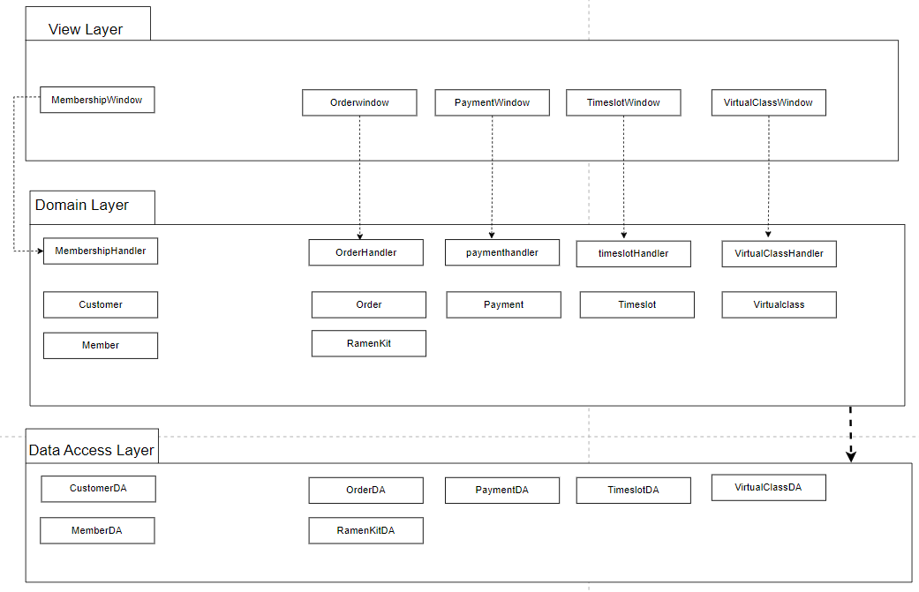

## CRUD Table

|  |  |  |  |  |  |  |  |  |
| --- | --- | --- | --- | --- | --- | --- | --- | --- |
| Use Case \ Domain | Customer | Member | Manager | Order | OrderItem | OnlinePayment | Virtual Class | Timeslot |
| Apply Membership | R | C |  |  |  |  |  |  |
| View Benefits |  | R |  |  |  |  |  |  |
| Purchase Ramen kits |  | R |  | C | C |  |  |  |
| Make Online payment |  | R |  |  |  | C |  |  |
| View Virtual Class |  | R | R |  |  |  |  |  |
| Create Virtual Class |  |  | R |  |  |  | C | C |
| Delete Virtual Class |  |  | R |  |  |  | D | D |
| View Timeslot |  | R | R |  |  |  |  | R |
| Update Timeslot |  |  |  |  |  |  |  | U |
| Make Booking |  | R |  |  |  |  |  | C |
| Cancel Booking |  | R |  |  |  |  |  | D |

# Question 5

Waterfall model:

* The reason as to why we applied the waterfall model approach to our system is because it is an easy-to-understand model and because the requirements are clear and well-defined enough to follow. We used it because we are only implementing additional features that both address the needs of the users and enhance their experience. ‌(Reqtest, 2019)
* In addition, we took the waterfall approach because there is little to no technological risk at all in this straightforward project. As a result, the team is able to establish and work towards an end date in one-go, without the constant need to repeat each phase. (Lucid content team, 2017)

# Question 6

Lastly, we have applied the User Acceptance Test method to ensure whether we have successfully met the user’s needs and requirements before concluding the software development.  
  
Our team made the decision to incorporate the User Acceptance Test during the implementation stage mainly because we want to guarantee that there are no errors prior to deployment. We based the UAT on the use cases and user stories that we curated to serve as the foundation to address the problems within our System Vision Document. Furthermore, we used these inputs to develop the test scenarios for the system users to test. Afterwards, the development team will proceed to set up the former system to integrate the newly created extra functionality features. The newly introduced features will be subsequently tested out by the staff and managers for its functionality.

Among other duties, the project manager will be responsible for receiving feedback, monitoring the progress with constant updates and regulated checks to ensure that the system is up to par as well as communicating with the rest of the team whether revisions of the software are required to be done.

# Conclusion

Our team has proposed a thorough solution to counter the issues Menya Musashi’s internet platform is facing.  We had decided to implement a membership function that would allow customers who have successfully signed up as a member to be able to enjoy exclusive membership benefits such as ramen kits as well as partake in virtual cooking classes. Through this feature, there will be a significant increase in customer involvement and a steep rise in customer loyalty.

Moreover, we made the choice to construct this system by utilising the waterfall technique. By adopting the waterfall technique, we adhered to a set of guidelines and procedures. These guidelines assisted us in fulfilling our requirements and creating a development strategy that addresses the issues while improving customer engagement. Thereafter, a User Acceptance test will be implemented in the process. User acceptance testing is one of the most crucial procedures that is required for our system. The user acceptance testing helps evaluate and document the system to ensure that the user requirements have been met and is ready for deployment. Furthermore, by offering simplicity and personalised experiences, this system enhances the customers online experience which greatly benefits the business overall.

# Appendix

1. menyamusashi.com.sg. (n.d.). *Menya Musashi*. [online] Available at: https://menyamusashi.com.sg/ [Accessed 12 Aug. 2023].
2. Lucid content team (2017). *The Pros and Cons of Waterfall Methodology*. [online] Lucidchart.com. Available at: <https://www.lucidchart.com/blog/pros-and-cons-of-waterfall-methodology>.
3. Reqtest. (2019). *Waterfall Methodology is Dead? Long Live Waterfall!* [online] Available at: https://reqtest.com/en/knowledgebase/what-is-waterfall-methodology/#:~:text=Planning%20resources%20for%20Waterfall%20is [Accessed 12 Aug. 2023].